K230593 Muhammad Ayesh

Data Structures – Lab -06 Stack and Queues

Task-1

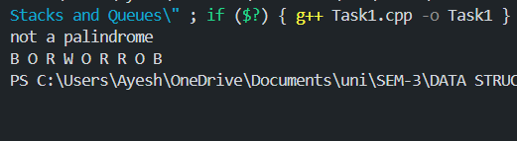

Task-2

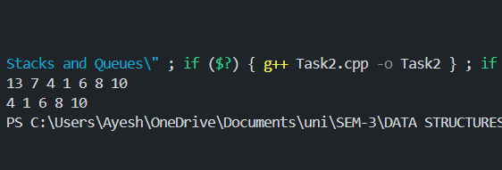

Task-3

